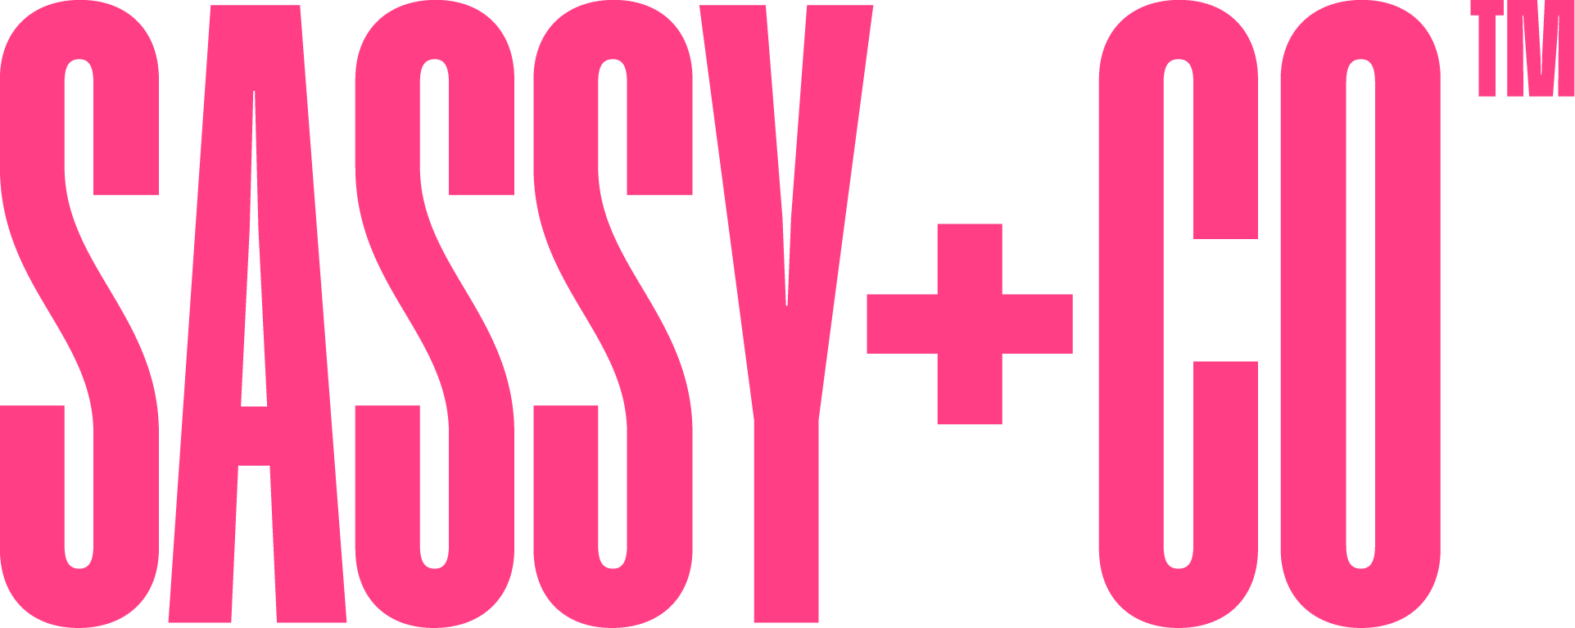
A Sneak Peek, Fresh Samples, and Sunny Savings Inside!
We are so excited to send this package your way! Tucked inside you'll find samples of our brand-new Luxurious Triple Milled Bar Soap, our Summer Catalog Supplement showcasing new products and dazzling displays, and a Competitive Overview for Bar Soap to help you see just how well we stack up. Read on for all the details, plus a reminder about our Show & Road Special that's running now through August 30th!
Introducing: Luxurious Triple Milled Bar Soap
Ship date: July 25th — and trust us, it's worth the wait. This soap is GORGEOUS! Embossed, gift-boxed, and available in 6 beautiful fragrances, it's the kind of product that sells itself the moment a customer holds it.
- 5 oz size, embossed and gift boxed
- 6 gorgeous fragrances to choose from
- $6.00 wholesale cost

Gorgeous New Acrylic Displays
Show off your products in style! New displays include:
- Bar Soap Display  - Lip Butter Display  - Lip Tint Display | - Spa Display — holds 4 items from one fragrance, customizable with most products!  - NI Spa Mini Hand Crème Display (similar to Sassy) — AMAZING!

Introducing: Sassy Holiday Dreamer Gift Sets
Ship date: October 1st. These gift sets are ready to wrap and give — a perfect holiday grab!
- 6 Gift Sets per assortment
- Includes 2 oz Mini Hand Crème, Lip Butter, and Sassy Dreamer Red Satin Pillowcase
- $14.00 cost, case packs of 4

Show & Road Special — June 1 through August 30
Don't forget — these savings are live right now, so keep them in your back pocket for every show and every road stop!
Sassy Holiday | A $500 Sassy Holiday order qualifies for a 10% freight cap AND 1 free case (6 units) of holiday mini hand crème in a former fragrance, while supplies last — a $30 wholesale value! Ship date 10/1.
All Orders | Any order (can include NI Spa and Sassy) of $500+ qualifies for a 10% freight cap, with one ship date and one ship-to location.

What's Enclosed
This package includes everything you need to get excited and get selling:
- Sample of our new Triple Milled Bar Soap
- Our Summer Catalog Supplement, featuring new products and new displays
- A Competitive Overview for Bar Soap, so you can see how we compare

Thank you for all you do — your energy and hard work are what make this company shine. We can't wait to see this new soap and these beautiful displays out at your shows and on the road this summer!
With so much appreciation,
Your FMG Team

